Dual LED Flasher  
Build Instructions  
  
Parts List:

Breadboard, with rails.  
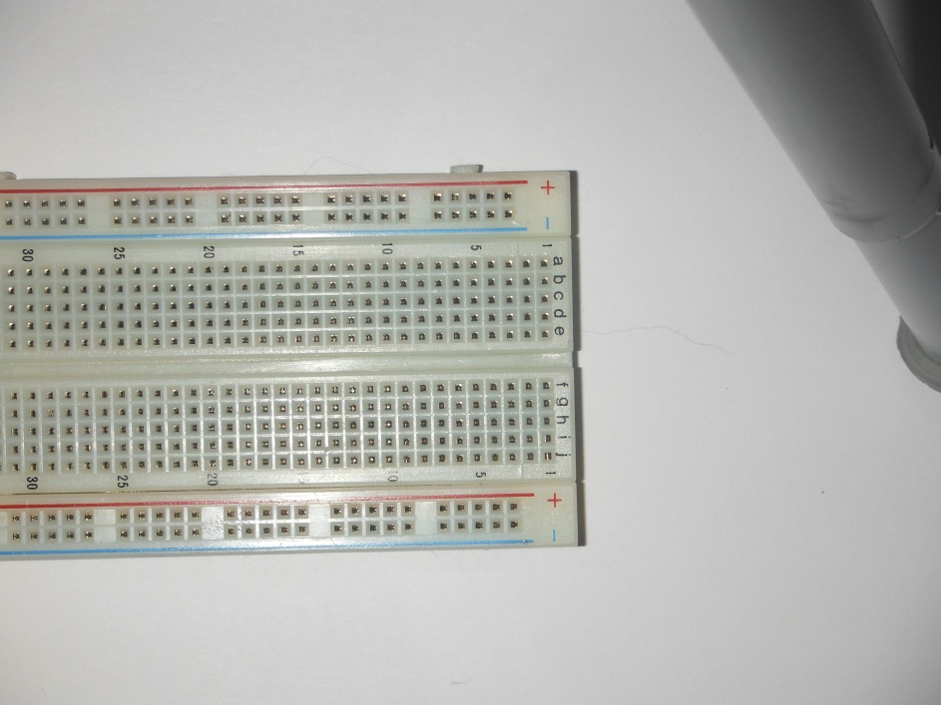  
  
2x 470 Ohm (Yellow, Purple, Brown) Resistor   
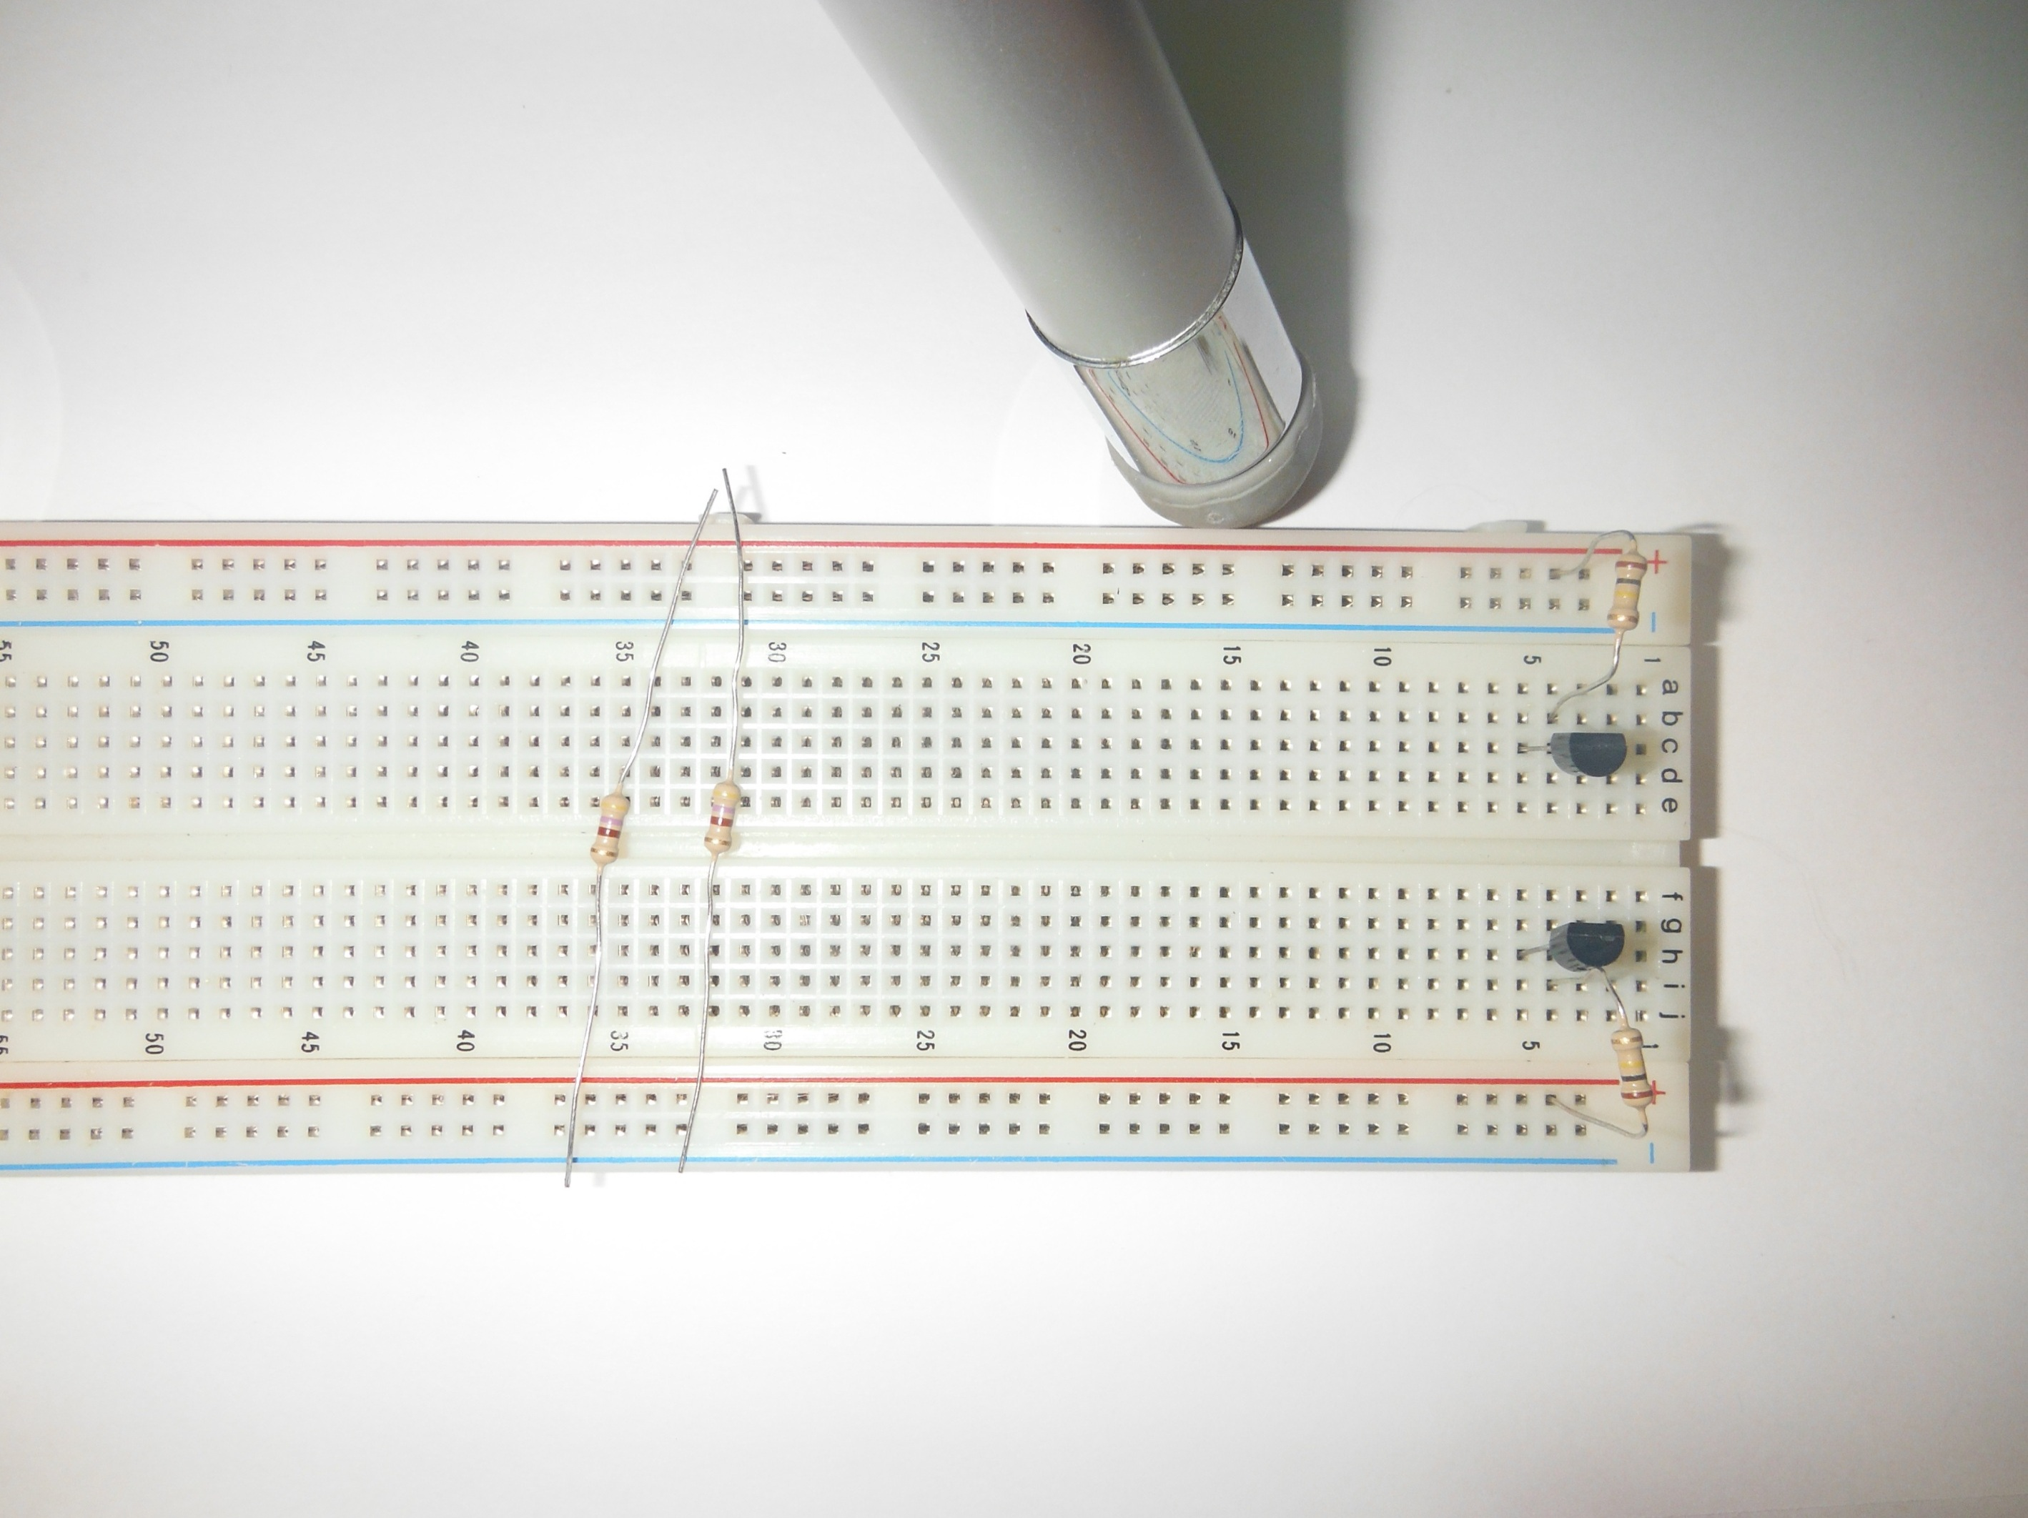

2x 100k Ohm (Brown, Black, Yellow) Resistor  
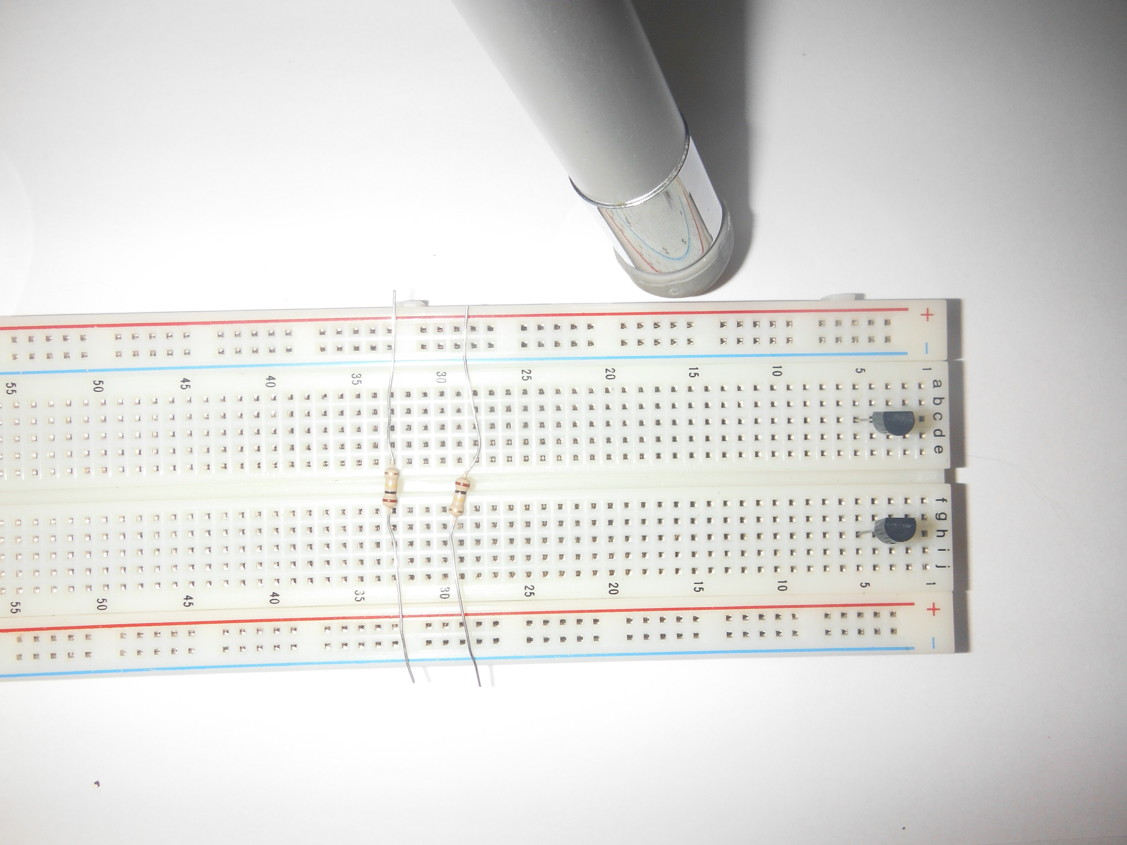  
  
2x Light Emitting Diode (LED)  
Polarized, Long Leg Positive  
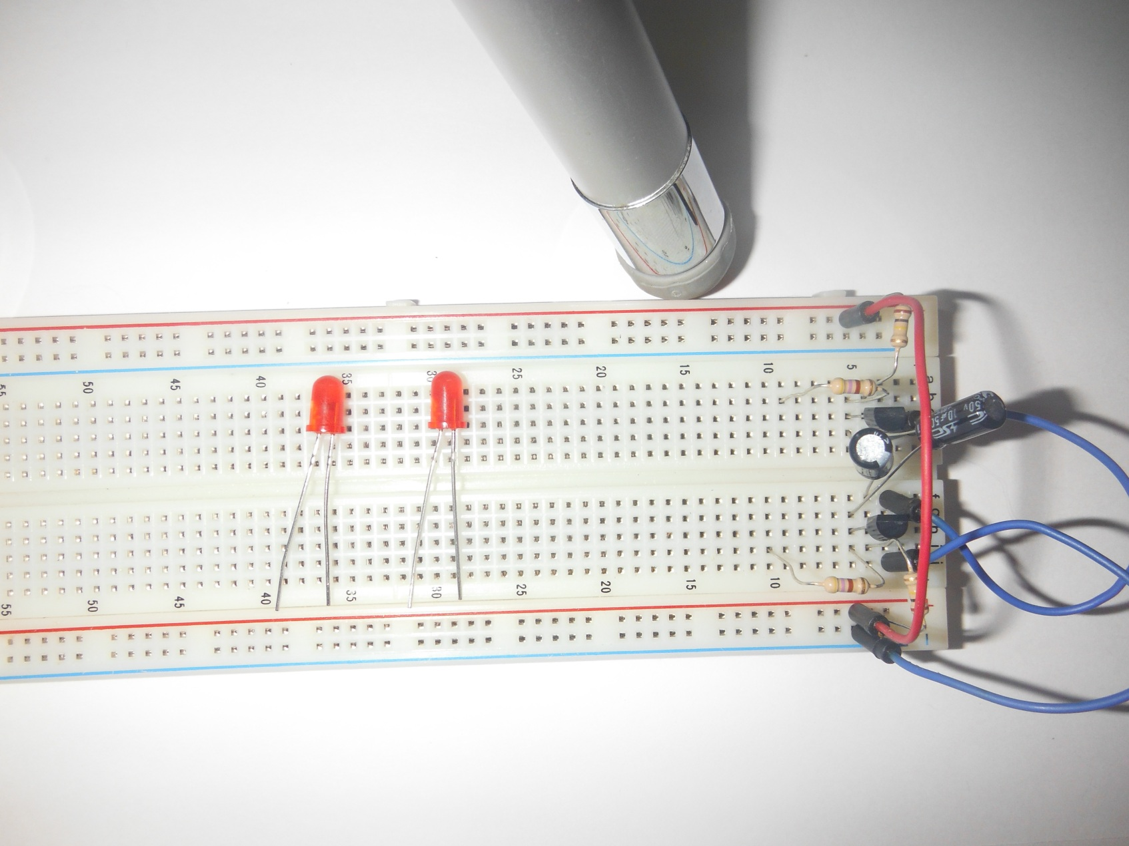

2x Electrolytic Capacitor  
Polarized, Long Leg Positive  
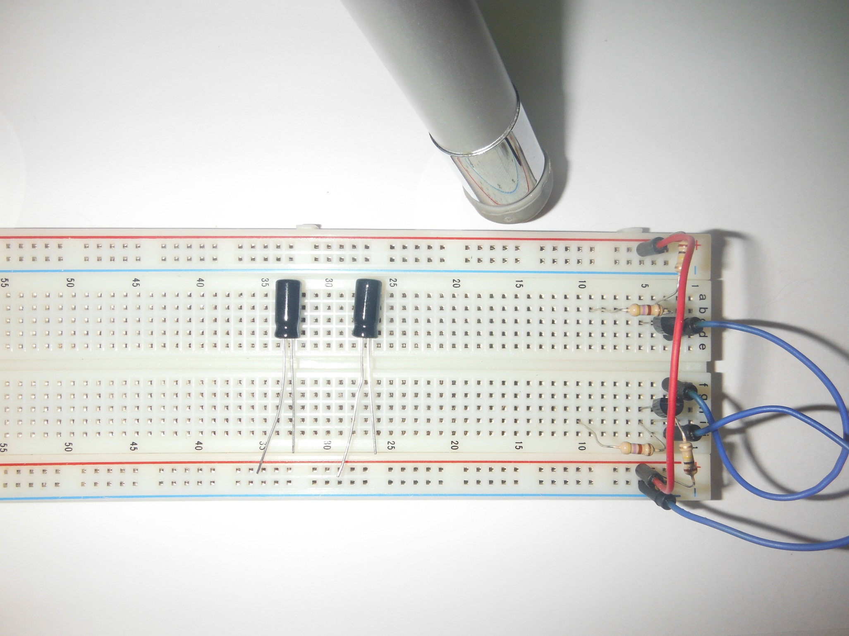

2x 2n3094 Transistors  
Polarized, Round End Up  
Collector (C), Base (B), Emitter (E)  
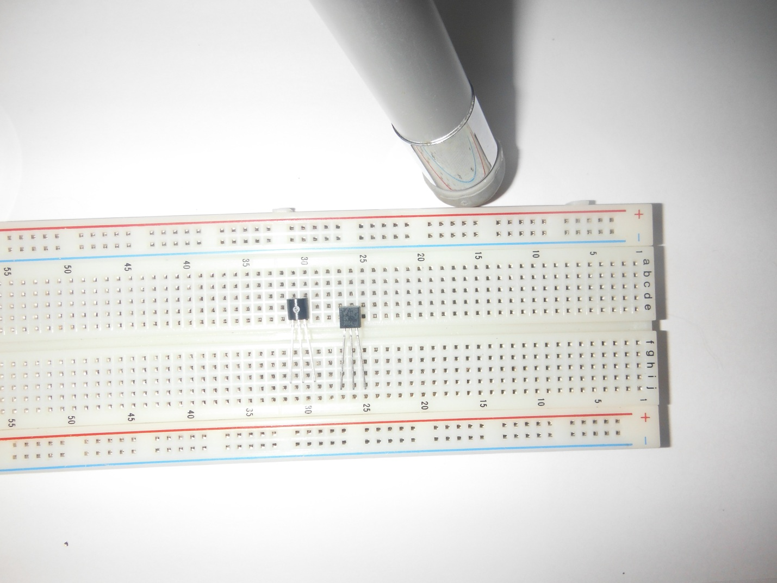  
  
Directions:  
A text description will be given:   
1) Insert 100K Ohm Resistor, from Base (B) of each transistor (Column 4), to Positive (Red) Rail  
Then a more concise grid based description will be given:  
100K Ohm Resistor A4 to PR  
100K Ohm Resistor J4 to NR  
Where PR is Positive Rail, and NR is Negative Rail  
In the case of polarized components, + and – will be used, referring to legs on the component.  
LED A10- to PR+  
LED J10+ to NR-  
In the firse case, LED short leg goes into A10, while long leg goes into Positive Rail.

1) Position breadboard with numbers starting on the right.  
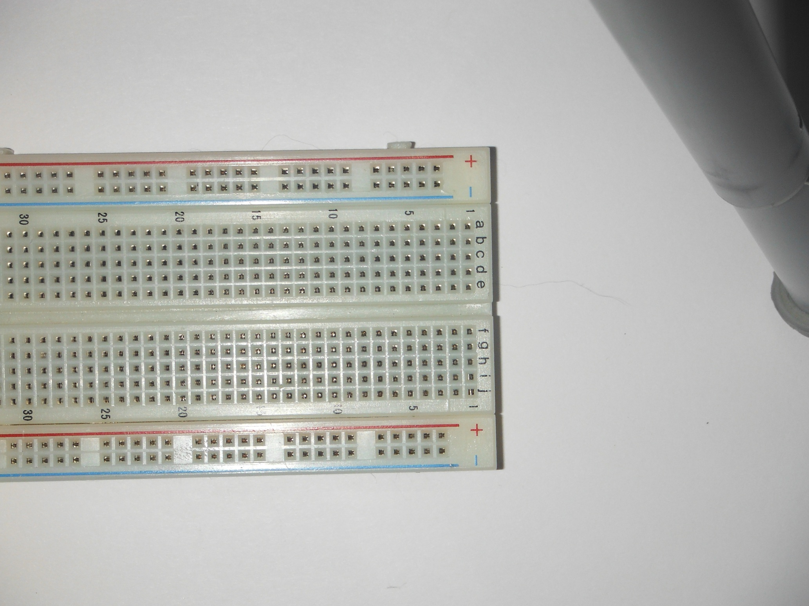  
  
2) Insert two transistors, flat side facing up (CBE), C in column 5, E in Column 3.  
Transistor, flat part facing away from you, C5 through C3  
Transistor, flat part facing away from you, H5 through H3  
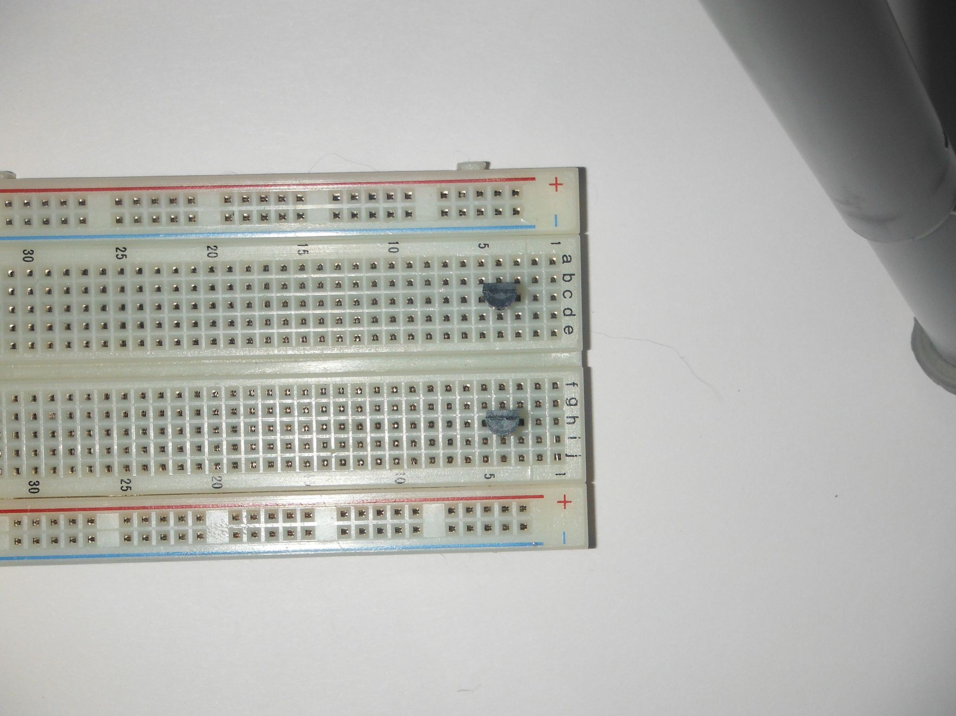

3) Insert 100K Ohm Resistor, from Base (B) of each transistor (Column 4), to Positive (Red) Rail  
100K Ohm Resistor A4 to PR  
100K Ohm Resistor J4 to PR  
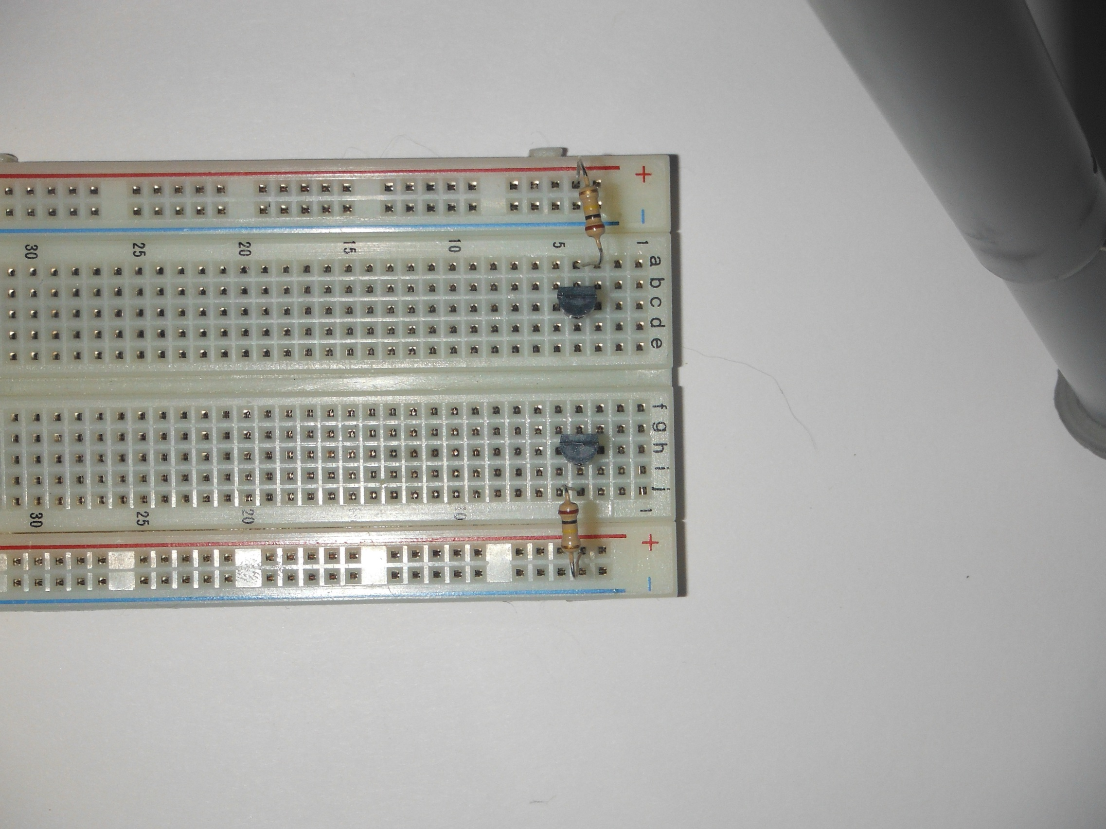

4) Insert 470 Ohm Resistor, From Collector (C) of each transistor (Column 5), to Colum 10.  
470 Ohm Resistor B10 to B5  
470 Ohm Resistor G10 to G5  
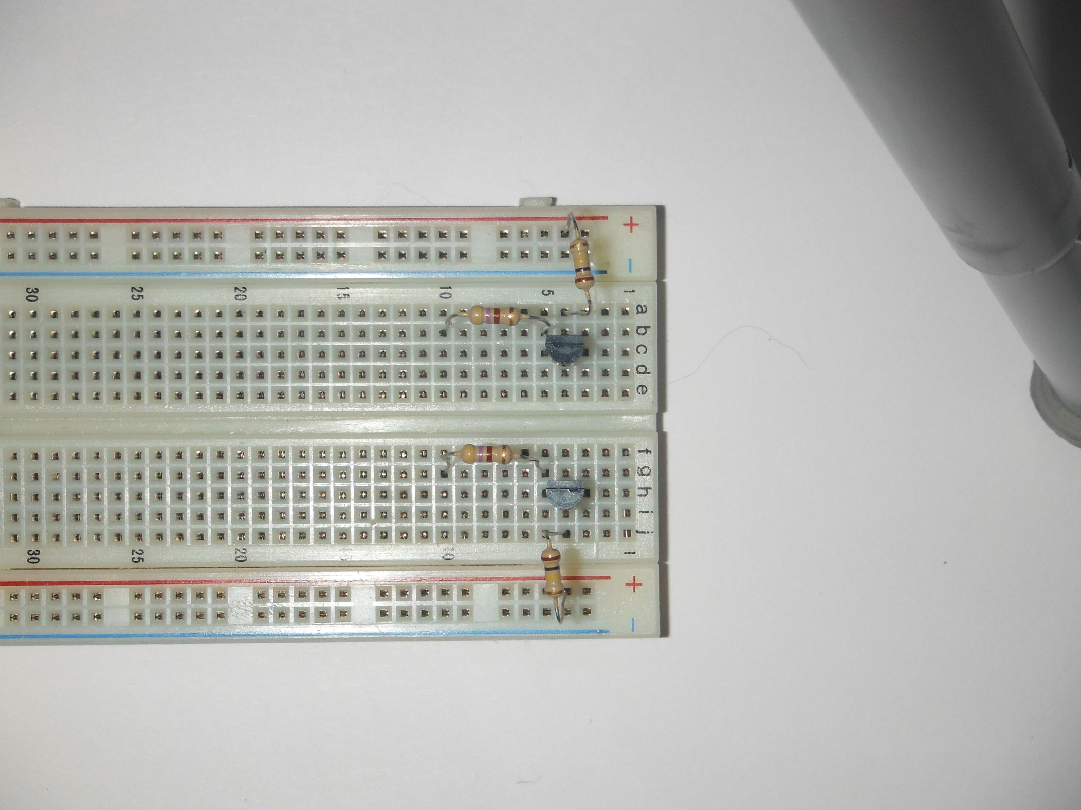

5) Insert LEDs from Column 10 to Positive Rail (Red), Long Leg.  
LED A10- to PR+  
LED J10+ to NR-  
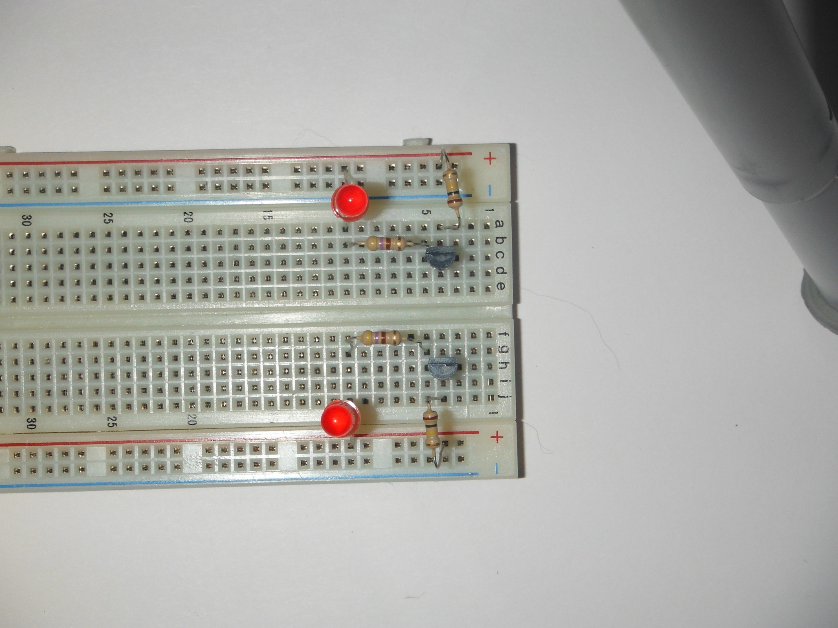  
  
6) Insert capacitor, Long Leg at upper transistor Collector (C) Column 5, Short Leg at lower transistor Base (B) Column 4.  
10uf Capacitor E5+ to F4-  
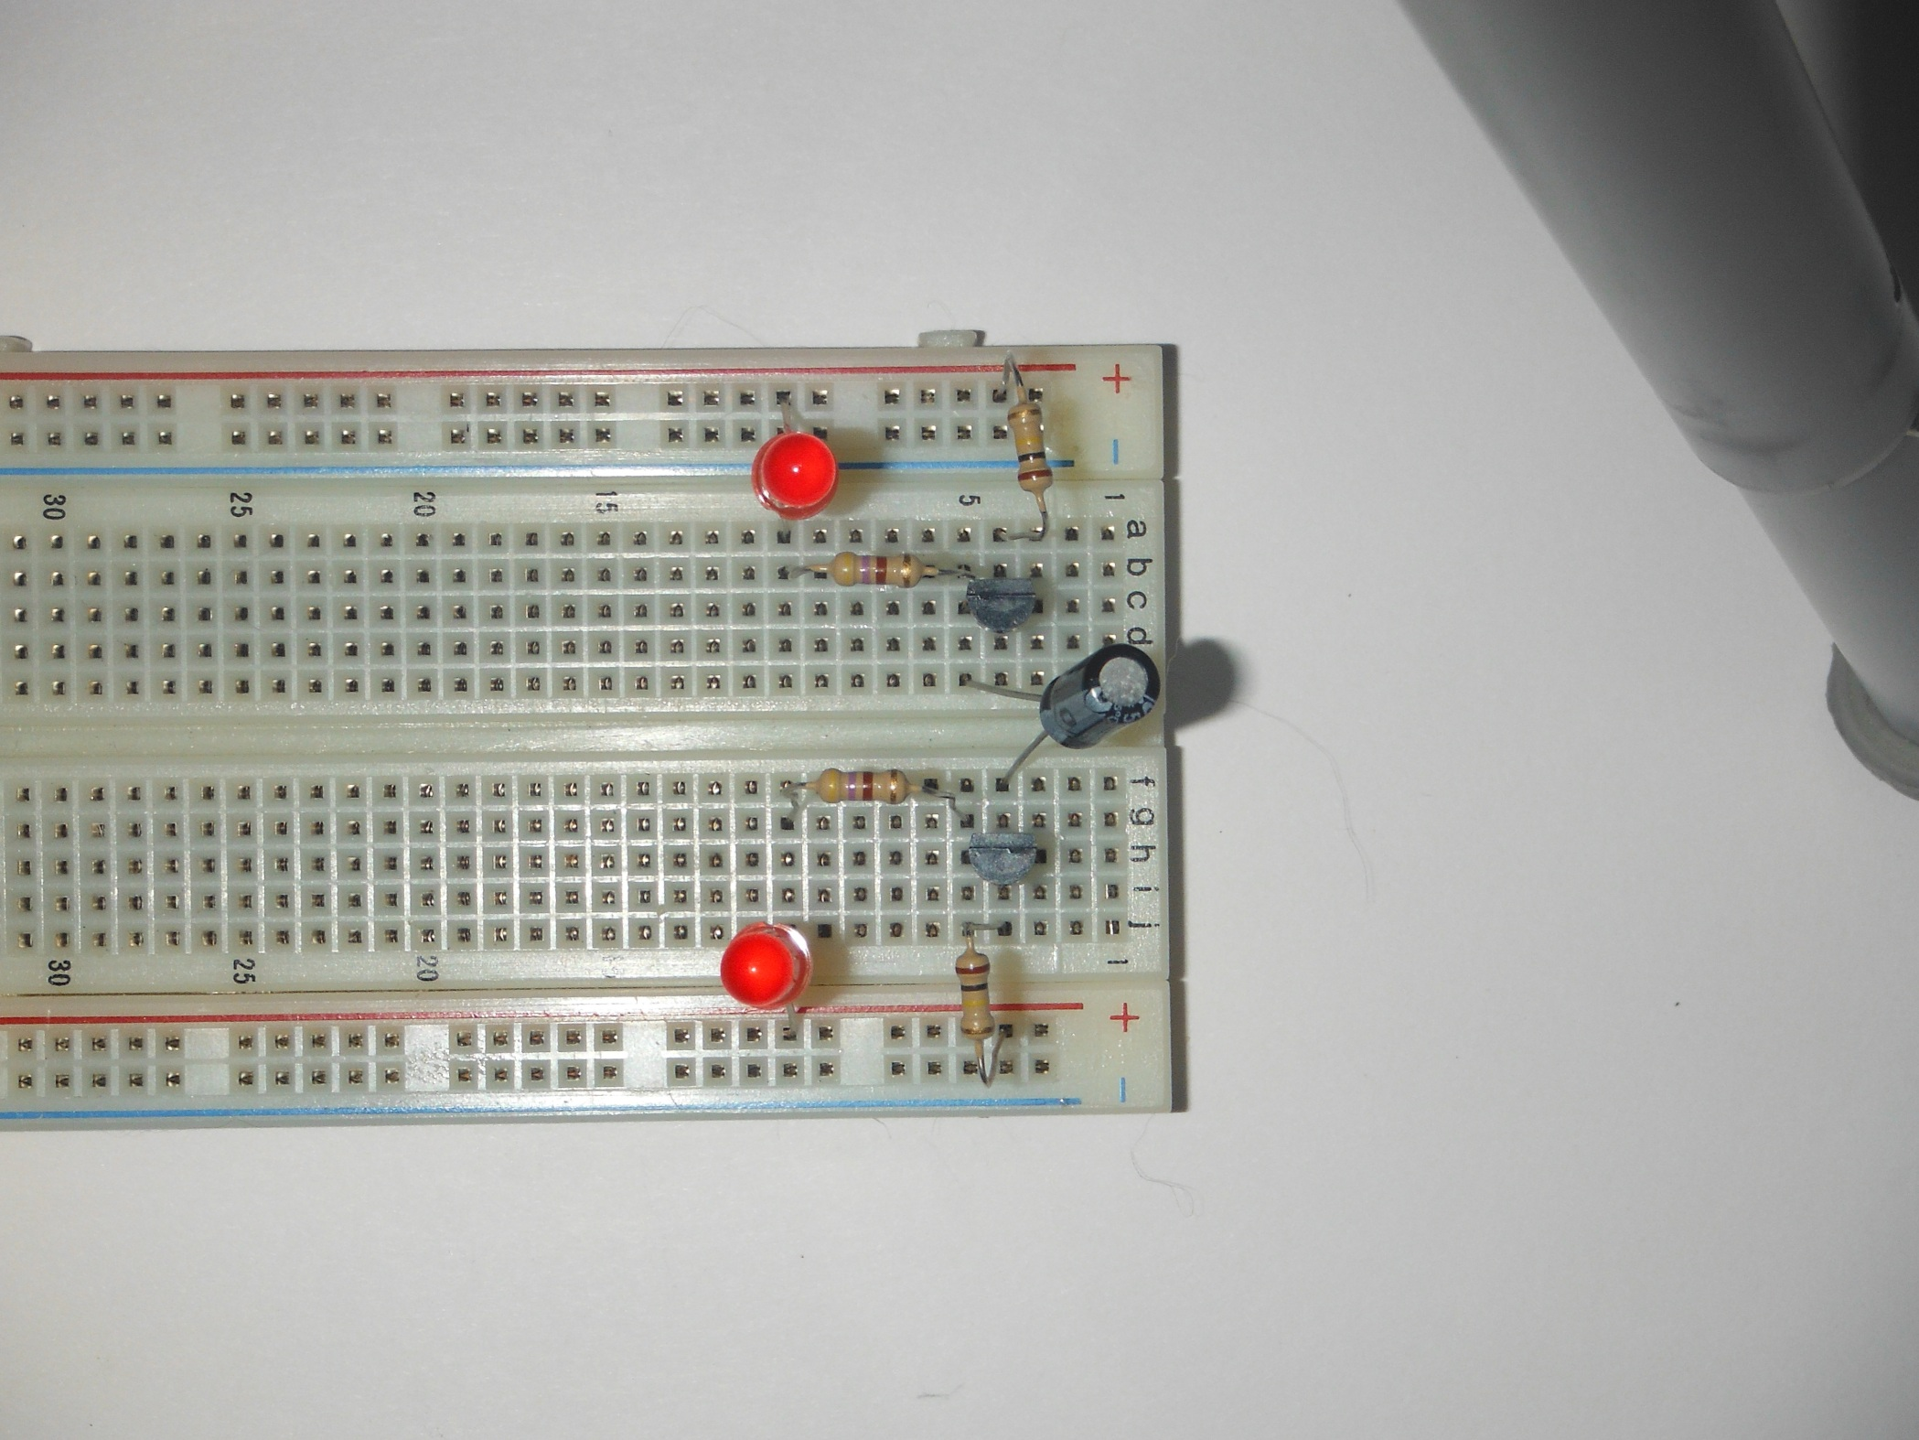

7) Insert Capacitor, Short Leg at upper transistor Base (B) Column 4, Long Leg as lower transistor Collector (C) Column 5. Adjust capacitors so that legs do not touch.  
10uf Capacitor F5+ to D4-  
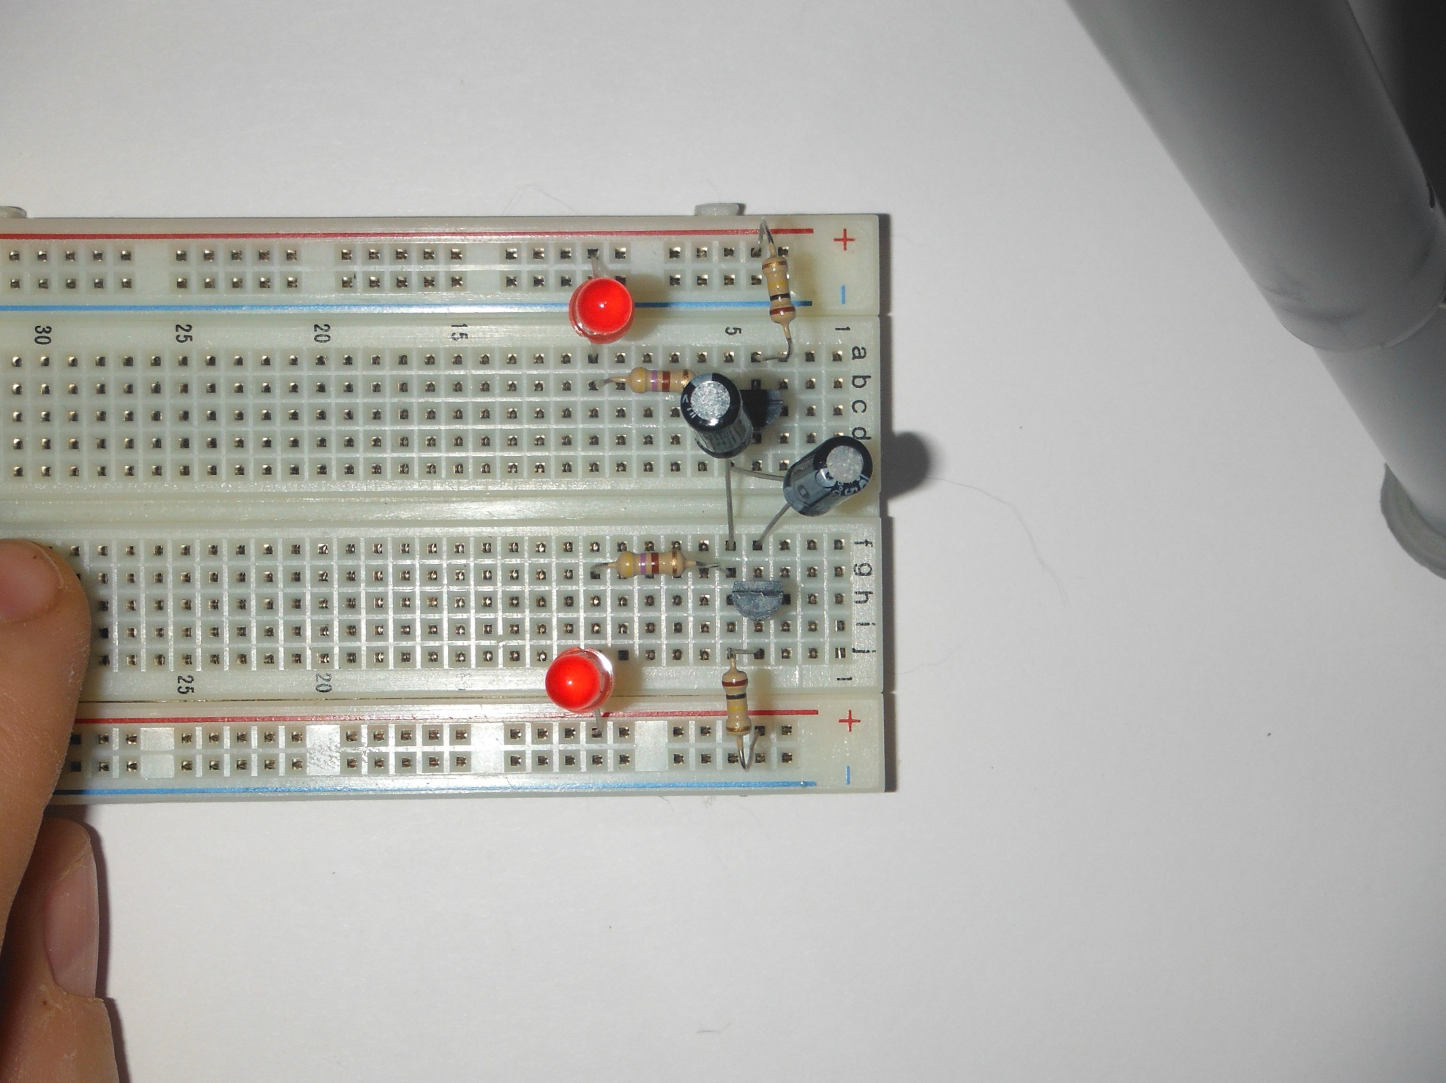  
  
8) Tie Positive Rails together.  
Jumper PR to PR  
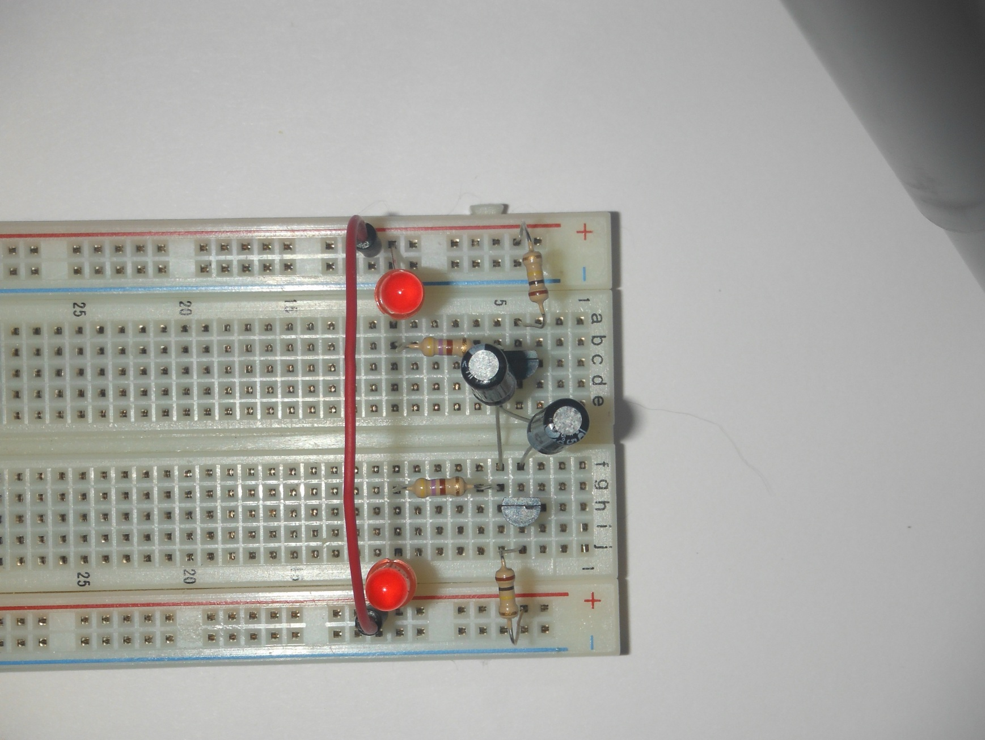

9) Jumper top transistor emitter (E) column 3, to bottom transistor emitter (E) column 3.  
Jumper E3 to F3  
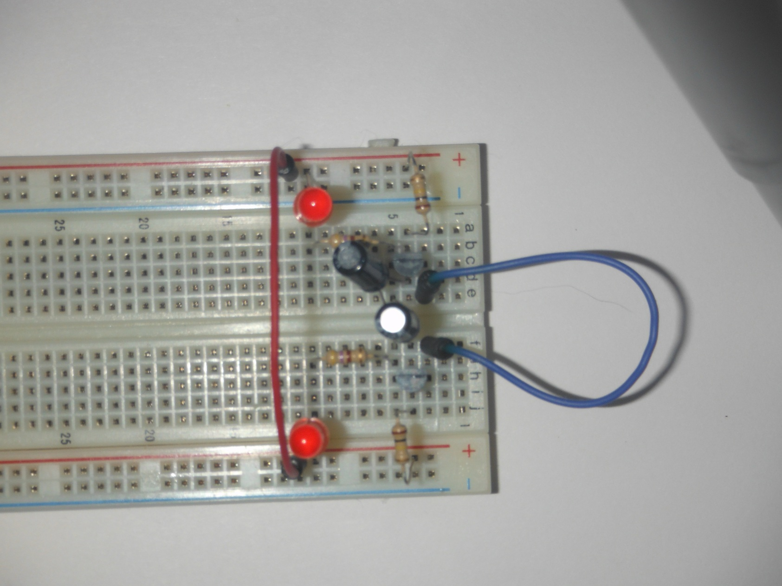

10) Jumper bottom transistor emitter (E) column 3, to bottom Ground Rail.  
Jumper J3 to NR  
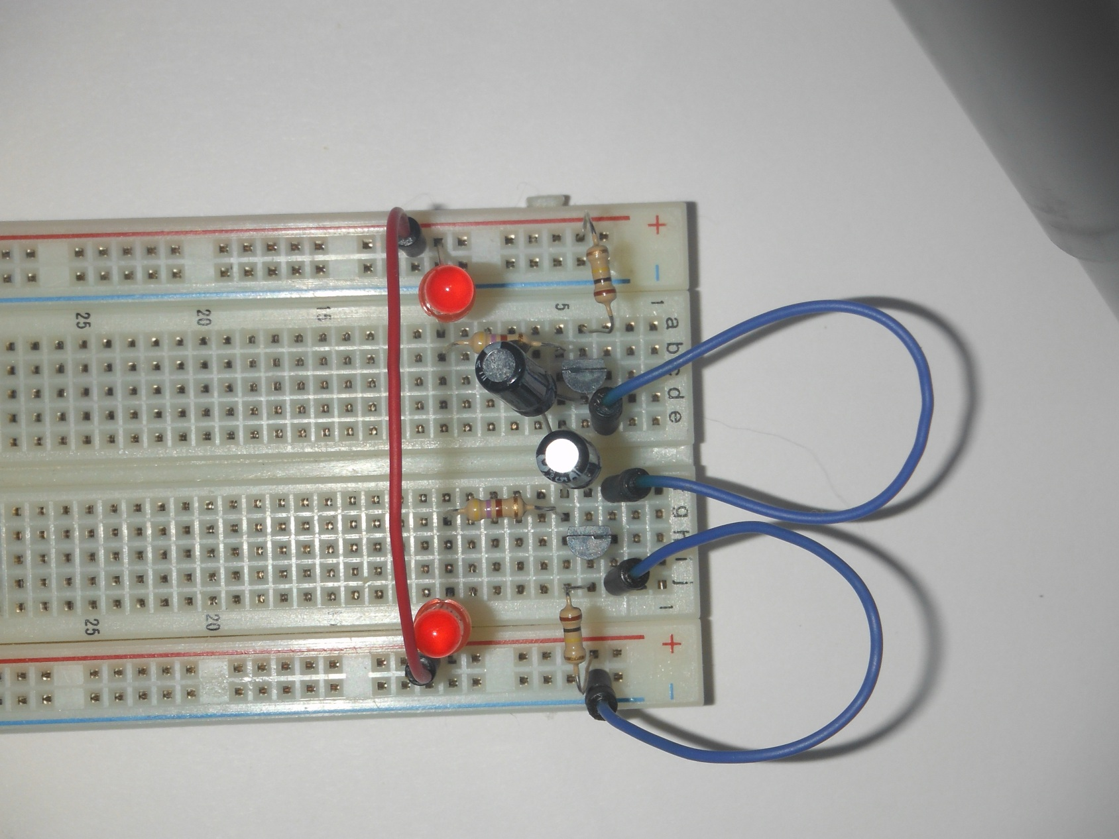  
  
10 Attach Battery, Ground to bottom Ground Rail, Positive to Positive Rail.  
Light Emitting Diodes, LEDs will immediately start blinking.  
Battery Positive (red) to PR  
Battery Negative (black) to NR  




